Taking Scientists to School:

Using Nevada’s Climate Research for K-12 Science Learning

This series of lessons focuses on some of the exciting climate change research that is the result of the multidisciplinary effort conducted through the Experimental Program to Stimulate Competitive Research (EPSCoR) program created by the National Science Foundation (NSF).

There are so many people working to understand climate change in Nevada: how we affect it and how it affects us. Within these lessons, students get to learn about research taking place now in Nevada and, more importantly, will be able to use the research they learn about to spark their own interest and understanding in areas related to climate change.

Each lesson is designed so that students can explore information related to climate change and form their own ideas about research questions they are presented with. They will then use the EPSCoR researcher’s expertise to evaluate their explanations before sharing their ideas with their classmates.

For this lesson, students will explore how a person’s understanding of the principles of climate change affects their willingness to act to adapt to or mitigate the effects of climate change. They will collect evidence to work toward answering the overarching question:

**WHAT AFFECTS HOW WILLING WE ARE TO TAKE ACTION ON CLIMATE CHANGE?**

**Time to complete:** 4 to 6 days

**Grade level:** 9th to 12th grades

**Standards:**

**NGSS**:

*Science and Engineering Practices*:

* Asking questions
* Planning and carrying out investigations
* Constructing explanations
* Engaging in argument from evidence
* Obtaining, evaluating, and communicating information

### Developing and Using Models

### Analyzing and Interpreting Data

### *Disciplinary Core Ideas*:

### *Crosscutting Concepts*:

### Patterns

### Stability and Change

**INTRODUCTION**

People have very different ideas about climate change: how it is happening, what governments and other large organization can do about it, and what we as individuals can do about it. Our opinions and actions on most things are shaped by our experiences and understanding; like the people we know, where we live, or the things we have learned in school. Our opinions and actions regarding climate change are no different.



Gabriel Young and the research team he works with at the University of Nevada-Las Vegas are studying these effects. He has been researching how our understanding of climate change and its impacts affects our willingness to act to adapt to or mitigate the effects of climate change. You will learn about similar research later in the lesson.

For this lesson, you will be exploring the same ideas to make claims about what YOU think it means to be resilient to climate change and what we can do in our communities to ensure that we are.

**How This Lesson Works**

This lesson is focused on a **Big Question.** The activities are divided into different sections or features.

1. With feature one of the lesson, you will be asked to respond with your initial ideas related to the Big Question. In every additional feature of the lesson, you have the opportunity to provide any further thoughts or questions that arise.
2. Feature two of the lesson is an activity where you are required to collect and explore some evidence related to the science content of the Big Question. This evidence is used throughout the remaining features of the lesson.
3. Feature three of the lesson involves analyzing your evidence and using it to generate an explanation (also called a claim) about the scientific ideas of the lesson. Typically, your analysis will produce an artifact that you will describe and justify to your peers and teacher at Research Council.
4. The accepted scientific understanding of the lesson is presented in feature four. In addition to demonstrating a thorough understanding of the scientific knowledge of the content, you will be asked to compare and contrast your explanation from feature two.
5. Finally, feature five of the lesson involves sharing and justifying your explanation and artifact from feature three among your peers and with your teacher at Research Council. The culminating activity of the lesson is to reflect on the Big Question of feature one and synthesize your understanding by using your evidence to compare and contrast your ideas with those of your peers and teacher.

**The Big Question**

In this lesson you will explore the **Big Question** below and work through five different steps to address it. At certain points, you will be asked to complete a few activities like: reading, responding to some thoughtful questions, and adding to your research brief. You should take your time and think carefully about each step of your work and feel free to revisit any step at any time. We will review the concepts in class.

**The Big Question:**

HOW DOES OUR UNDERSTANDING OF CLIMATE CHANGE AFFECT HOW WILLING WE ARE TAKE ACTION?



**FEATURE 1: YOUR INITIAL IDEAS**

In order to think about how our understanding of climate change affects our willingness to take action, we have to first address some smaller questions: What parts of our lives impact our beliefs? What actions could we take to reduce our impact on climate change?

1. Look at the images below and consider what parts of our lives have an impact on our beliefs and willingness to take action on climate change?

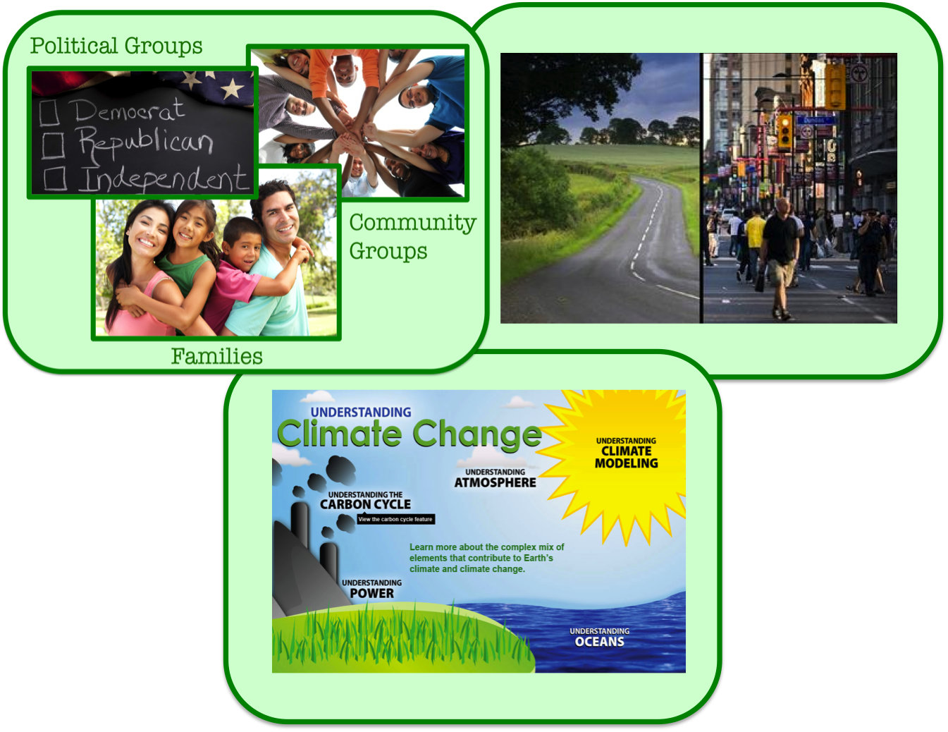

1. Watch the video clip below and consider what actions can be taken to limit the impacts of climate change:

<https://www.youtube.com/watch?v=_s9dxc_jVlY>



Research Brief: Getting Started

Use the following prompts to discuss some of your initial ideas about our actions related to climate change and what influences them.

1. What types of actions have an impact on climate change?

To minimize the effects of climate change, we can…

1. What influences our decisions with regard to climate change?

Our willingness to act to minimize the effects of climate change is influenced by…

1. How might our understanding of climate change affect our willingness to act to adapt to or change its impacts?

Our understanding of climate change might affect how willing we are to act, because…

**FEATURE 2: EXPLORE THE EVIDENCE**

**Task 1: Evaluate the survey**

To answer the big question, we need to gather some information on what people know about climate change and what they do about it. One way researchers do this is to conduct a survey and you will do the same thing for your first evidence-gathering task.

You already have some ideas for what actions people can take to limit their effect on climate change. Willingness to take action on climate change is our **dependent variable.** It is the thing that we are trying to explain. We are trying to find out if it is *dependent* upon how much someone knows about climate change.

Climate change understanding is our **independent variable.** It is what we think might have an effect on our dependent variable. We don’t know how climate change might affect our actions, but that is what we are trying to figure out. This variable is called *independent*, because, for the question we are asking, the other variable does not affect it. It affects something else.

The survey below can be used to learn more about how your peers, parents, teachers, coaches, neighbors, etc. know about climate change and what action they take to limit their impact. The survey was created from surveys that other researchers have used in the past.

There are several questions asked about each topic. Review the survey with your group. Is there anything that you would add to it? Are there any questions that don’t seem important that you would take away?

**CLIMATE CHANGE SURVEY WITH ANSWERS**

**Does our climate change knowledge affect our climate change behaviors?**

The first part of this survey (10 multiple choice and true/false items) is intended to see how much you might already know about climate change. Read each question carefully and answer to the best of your ability. Some questions may have more than one correct answer. Select all answers that you believe to be correct. If you do not know the answer, select the response, “Don’t know.”

Adapted from: Yale Project on Climate Change Communication

“American’s Knowledge of Climate Change”

1. The “greenhouse effect” refers to:
   1. gases in the atmosphere that trap heat.
   2. the Earth’s protective ozone layer.
   3. pollution that causes acid rain.
   4. how plants grow.
   5. don’t know.

[Correct answer: gases in the atmosphere that trap heat]

1. Which of the following gases in the atmosphere are good at trapping heat from the Earth’s surface? Circle all that apply.
   1. Carbon dioxide
   2. Methane
   3. Water vapor
   4. Hydrogen
   5. Oxygen
   6. Don’t know

[Correct answers: carbon dioxide, methane, and water vapor. Incorrect answers: oxygen and hydrogen.]

1. Weather often changes from year to year.
   1. True
   2. False
   3. Don’t know

[True]

1. Climate is the average weather conditions of a region.
   1. True
   2. False
   3. Don’t know

[True]

1. In the past, rising levels of carbon dioxide in the atmosphere have caused global temperatures to increase.
   1. True
   2. False
   3. Don’t know

[True]

1. Which of the following are “fossil fuels”?
   1. Coal
   2. Oil
   3. Natural gas
   4. Wood
   5. Hydrogen
   6. Solar energy
   7. Don’t know

[Correct answers: coal, oil, and natural gas. Incorrect answers: wood, solar energy, and hydrogen.]

1. What gas is produced by the burning of fossil fuels? *(order of items randomized)* 
   1. Oxygen
   2. Hydrogen
   3. Helium
   4. Carbon Dioxide
   5. Don’t know

[Correct answer: carbon dioxide]

1. Global warming will cause some places to get wetter, while others get drier.
   1. True
   2. False
   3. Don’t know

[True]

1. The decade from 2000 to 2009 was warmer than any other decade since 1850.
   1. True
   2. False
   3. Don’t know

[True]

1. Global warming will cause temperatures to increase by roughly the same amount in all countries.
   1. True
   2. False
   3. Don’t know

[False]

The second part of this survey (10 items) makes statement about habits related to climate change. Read each question carefully and decide whether the statement is true or false for your personal habits. Select one answer.

Adapted from : The Stanford Climate Change Behavior Survey (SCCBS)

1. I have taken part in a political campaign about an environmental issue.
   1. True
   2. False
2. I have contacted a government member about climate change.
   1. True
   2. False
3. I try to conserve my usage of electricity.
   1. True
   2. False
4. Most of my cleaning products are environmentally friendly.
   1. True
   2. False
5. I have switched to products that are more environmentally friendly.
   1. True
   2. False
6. Where possible, I buy products that are made locally.
   1. True
   2. False
7. I have reduced the amount of gas and/or electricity I use around the house and garden/yard.
   1. True
   2. False
8. I will usually try to fix things rather than replace them.
   1. True
   2. False
9. I have reduced the amount of water I use around the house and yard.
   1. True
   2. False
10. I switch lights off around the house whenever possible.
    1. True
    2. False

Use the survey to answer the questions below in your research brief.



Research Brief:

Use the following prompts to discuss some of your ideas about what questions to ask for both your independent and dependent.

1. Action taken to limit climate change is our dependent variable, because…
2. Climate change understanding is our independent variable, because…
3. We decided to/not to add questions to the survey because…

(Please list any questions added and why)

1. We took out/did not take out questions from the survey, because…

(Please list any questions taken out and why.)

**Task 2: Conduct your survey**

When you have reviewed the survey, print out 20 copies. The link below provides a copy of the survey without the answers. Having participants take the survey on paper is often simpler than asking the questions in person. Your survey takers might feel less like they have to give you the “right” answer.

Come up with 20 people that can take your survey. Some might be other students in your school, teachers at your school, your parents, or other people you interact with on a daily basis. Make sure the participants you choose do not see the answers ahead of time. Have the 20 people you choose complete the survey. Make sure the survey taker knows they don’t have to put their name on their survey. We don’t need to know who they are to calculate our results.

Climate Change Survey without Answers

**Task 3: Calculate and report results**

With your 20 responses, calculate the scores for each part of your survey separately (one score for the dependent variable, one score for the independent variable). Record the results in the table provided on your research brief.



Research Brief:

1. Put the surveys in order from low to high based on the independent variable score (i.e., the score for climate change understanding). In other words, the survey with the lowest score should come first, the one with the second lowest score second, and so on. Record each person’s independent variable score and dependent variable score side-by-side in the table below.

|  |  |  |
| --- | --- | --- |
| Participant | Independent Variable Score  (Climate Change Understanding) | Dependent Variable  Score  (Willingness to Take Action) |
| 1 |  |  |
| 2 |  |  |
| 3 |  |  |
| 4 |  |  |
| 5 |  |  |
| 6 |  |  |
| 7 |  |  |
| 8 |  |  |
| 9 |  |  |
| 10 |  |  |
| 11 |  |  |
| 12 |  |  |
| 13 |  |  |
| 14 |  |  |
| 15 |  |  |
| 16 |  |  |
| 17 |  |  |
| 18 |  |  |
| 19 |  |  |
| 20 |  |  |

1. Use your table and the grid below to plot each one of your survey taker’s scores. The independent variable (climate change understanding) is on the X-axis and the dependent variable (willingness to take action) is on the Y-axis. Follow the directions below to create your graph.

Look at the scores for Participant 1. Record their data point on the graph below by…

1. Count across the x axis for the number of points they received on the environmental knowledge part of the survey.
2. Then, count up the y axis for the number of points they received for the environmental action part of the survey.
3. Place the data point there.
4. Repeat these steps for each participant for each of the participants surveyed.

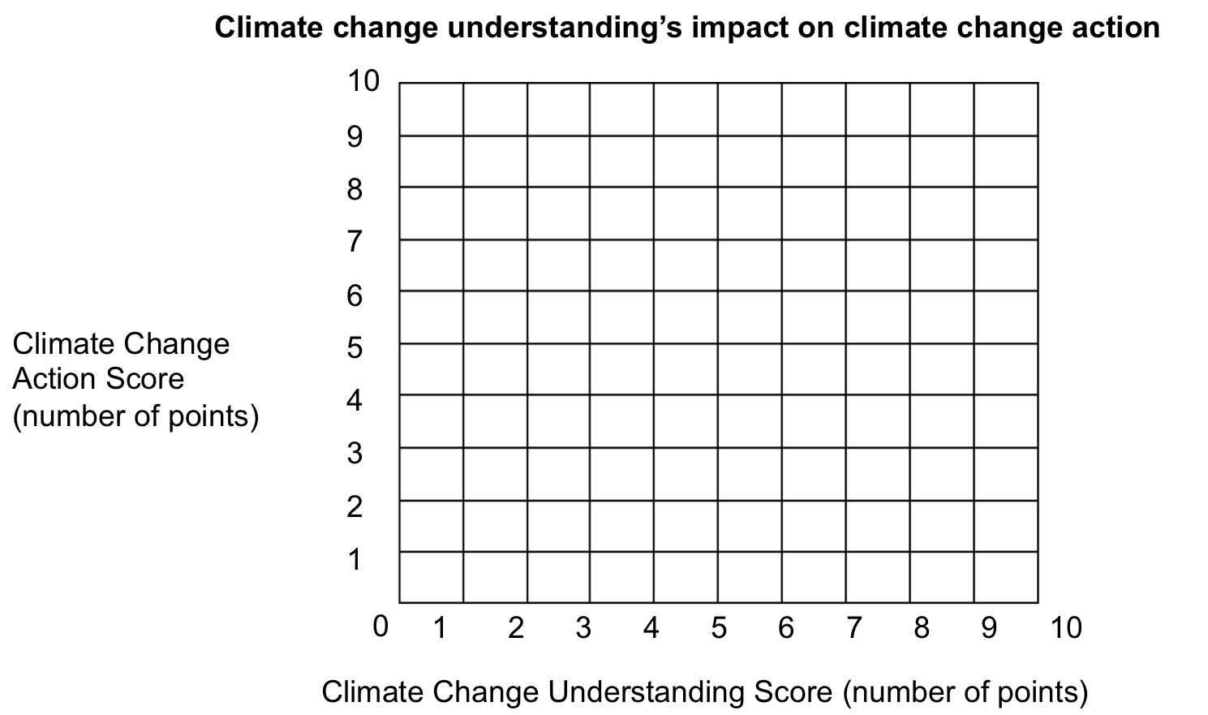

1. Do you see any relationships between a person’s understanding of climate change and the actions they take with regard to climate change?

The relationships I see between climate change knowledge and climate change actions are…

Or

I don’t think I see any relationships between a person’s understanding and behavior, because…

**FEATURE 3: YOUR SCIENTIFIC CLAIMS**

You have gathered, recorded, and examined data on both climate change understanding and climate change action. You now must develop claim-evidence-reason statements describing the relationship you see between these two things. The evidence you cite should come from your survey responses and the relationship you see (or don’t see) between the dependent and the independent variables. Use the Evidence-Claim-Reason table below to develop your claims. An example is provided.

|  |  |  |  |
| --- | --- | --- | --- |
|  | **As evidenced by…** | **I claim…** | **Because…** |
| 1. | The graph we created of climate change | that as climate change understanding increases, people do more to prevent climate change | as their scores for climate change understanding increase, so do their scores for climate change action. |
| 2. |  |  |  |
| 3. |  |  |  |
| 4. |  |  |  |

Use your completed ECR Table to create a claim statement for each action item you propose.

Example: As evidenced by the graph we created of climate change, I claim that as climate change understanding increases, people do more to prevent climate change, because as their scores for climate change understanding increase, so do their scores for climate change action.



Research Brief:

Complete the following starter prompts in your Research Brief:

Claim Statement Starter Prompts:

1. As evidenced by... I claim that ... because...
2. As evidenced by... I claim that ... because...
3. As evidenced by... I claim that ... because…

**FEATURE 4: SCIENTIFIC UNDERSTANDING**

Use the link to the website below to better understand the relationship between climate change understanding and behavior and how people feel about it. You don’t have to read the entire document, but at least read through the executive summary in the beginning. There are complex relationship involved. How do these ideas compare to you own?

[Climate Change Survey-The Environment: Public Attitudes and Individual Behavior](http://www.climateaccess.org/sites/default/files/SCJ%20GfK_The%20Environment%20Public%20Attitudes%20and%20Individual%20Behavior.pdf)



Research Brief:

Now that you have completed the activity and considered the relationship between knowledge and behavior, look back to your initial response to the big question: HOW DOES OUR UNDERSTANDING OF CLIMATE CHANGE AFFECT HOW WILLING WE ARE TAKE ACTION? and describe how your ideas have changed. Include how your collected evidence from the four tasks used in this lesson influenced your ideas.

**FEATURE 5: RESEARCH COUNCIL**

In this investigation, you explored the concept of climate change understanding and the impact it could have on whether or not someone acts to limit or prevent climate change. Your preparation required you to conduct a survey to gather information from the people around you on these two topics. You have explored the relationship between this dependent and independent variable. You did this by conducting a survey and analyzing the results.

Present your Research Brief at a Research Council comprised of your classmates. Explain and defend your findings. Critique the claims presented by other students and ask them to defend their understanding of resilience and what our communities might need to be more resilient to the effect of climate change.

Compare your ideas with others, critically evaluate your understanding of the connection between our way of living, the climate, and our future, then make any changes or update your research brief as you feel is appropriate. Record the specific evidence and reasoning that caused you to want to make any changes.

Research Brief:

After Research Council, complete your Research Brief by finishing the following statements:

My ideas are similar to others because . . .

My ideas are different because . . .

Note: Use your experience in this lesson and the evidence you collected to support your claims.